Project Manual
Project CCS-ITO

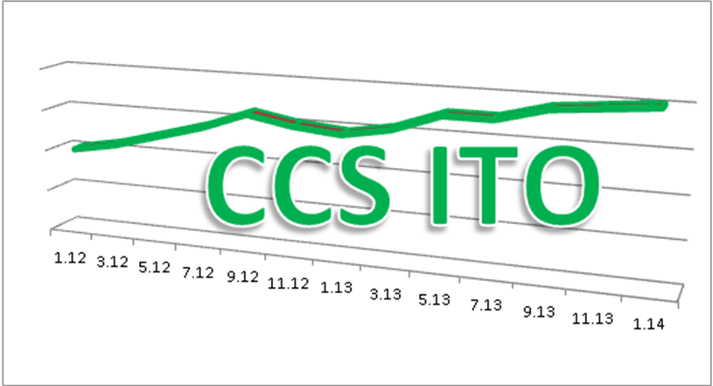

Version: | V1-2
Author: | Heinz Hirschi / Thomas Fürst
Date: | 27.02.2012 / printed: 27.02.2012

Revision

Version | Author | Changes | Date / Vis
V1-0 | Th.Fürst/H.Hirschi | Initial document | 14.02.2012 / fut,hih
V1-1 | Th.Fürst/H.Hirschi | Div.Anpassungen aus SC-Meeting vom 15.02.2012  - 4.Pilot ergänzt | 22.02.2012 / fut,hih
V1-2 | Th.Fürst/H.Hirschi | Pendenzen aus SC-Meeting integriert:  - Projektplan angepasst  - Projektorganisation | 27.2.2012 / fut,hih
Index of contents
1 Project Overview 3
1.1 Purpose 3
1.2 Major Tasks 3
1.3 Overall Project Schedule 5
1.4 Project Risks 5
1.5 Basics, Initial Position 6
1.5.1 Origin 6
1.5.2 SCM-Reports 7
1.5.3 Brainstorming with project aspects to be considered 8
2 Project Organisation 9
2.1 Organizational chart 9
2.2 Organisation for Pilot Phase with 4 customers 9
2.3 Points of Contact 10
3 Meeting Cycles 11
3.1 PL meeting 11
3.2 Project team meeting 11
3.3 Steering committee 11
4 Project schedule and resources 12
4.1 Projectplan 12
4.2 Project resources 13
5 Project Controlling 13
5.1 Reports 13
6 Regulations for project documentation 14

Project Overview

Purpose
ITO has a general high focus in the EMS sector. The stock situation in the CCS group is not satisfying, it reached 50% of the Material turn over ➔ ITO=2. CCH & CLK have installed the MTS (Make to Stock) system to increase control over the customer needs, but reduce the own risk level, because of the ability of identifying and charging excess material.
Deviated from the customer MTS control, the inventory should decrease to a acceptable level.
First experiences after installing the system didn’t show an effect on the stock situation.
Main goal of this project is to identify and eliminate bottlenecks and errors within this system and reduce the stock net value minimum 30% within 2 years group-wide.

Major Tasks

Major Tasks according to the milestones:

Major Task | Input | Output
Analysis CCH–CLK | Informations, Interviews, Reports, Observations | Detailed project schedule, bottlenecks, inputs & ideas for further project
Comments: | - Which process-steps are ERP-driven and which are manual or by Reports. What were the reasons to set up manually instead of ERP-driven?  - Which steps are more/less time consuming than before the MTS setup?  - Who/What role is using which information from the reports as described in 1.5.2 SCM-Reports?  - Disturbance handling: how is it handled within the process (late delivery, scrap, modifications in the product/within an order)?  - Deviations of commitments to customers against suppliers. Will it be analysed and will actions taken to synchronise?
MTS Pilot with 4 customer | MTS, 4 customer, x products and orders | Evaluation MTS  - Operations  - Inventory  Improvements  Potentials
Comments: | - Set-up “clean” MTS-System.  - Define criteria for successful completion of the pilot.  - Monitoring customer orders step by step through all processes (Order Planning, MRP, Purchasing, Material Input, Stock taking, Production, Delivery) and the stock dynamic of RM (Raw material) and FG (Finished Goods) along this timeline.  - Which role has a good sight on RM AND FG?  - During monitoring, implementation of findings from this and the previous task ➔ just one parameter at the time!  - Close cooperation with responsible PM’s.
Implementation CCH–CLK | MTS incl. improvements and further potentials | Running MTS system, monitoring, inventory reduction
Comments: | - Close cooperation with responsible staff in operation and related customers and suppliers.  - Appropriate training for the users.  - Implementation of all tested findings from the previous step.  - These are Quick-wins regarding the duration of this task.  - Implementation of reporting and monitoring system.  - Stabilization of processes and tasks
Analysis group-wide  - 1st prio: CAH-CAM  - 2nd prio: tbd | Informations, Interviews, Reports, Observations | Subsidiaries specific requirements, adjusted project schedule
Comments: | - This task is very different comparing to the first Analysis. The employees do not know MTS (exception: Sales) and there is no MTS-process prepared in the system.  - CAH-CAM works consequently with the ERP-order proposal, the IDD-Report is just for analysis purposes.  - This task is driven together with Process Owners and IT
Implementation group-wide | Subsidiaries specific requirements, MTS | Running MTS system, monitoring, inventory reduction
Comments: | - overall planning and coordination for the implementation  - Appropriate training for Key users and users  - Implementation step by step

Further Major Tasks, but not part of the CCS-ITO-Project:
- Reworking the past:
To reach the main goal, it is not only necessary to look and control actions in the future, but also in the present.
Therefore, the actual situation and actions like “No movers” analysis, not sold “excess material” will be also on focus within CCS.
The percentage of “old” overstocking in CCH-CLK is yet unknown.

- Group wide report consolidation:
The existing large reports generated from each ERP-System are not easy to consolidate. Initial actions were taken to build a data-warehouse.
The CCS-ITO project – especially in later phases – is depending on good and consolidated reports.

Overall Project Schedule
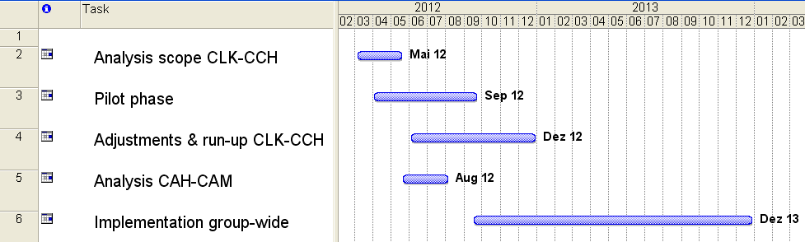

More detailed project planning see Chapter 4 Project schedule and resources.

Project Risks

Risk | Elimination measures
Delay in implementation because of under estimated complexity | PL assure priorities
MTS concept together with ERP-System(s) too complicated | Pilot
MTS in operation not efficient for low stock value | Pilot
Missing user acceptance for the MTS-System | Focus on specific user training in advance
Group-wide solution not possible due to customer and supplier specific requirements and behaviours | Pilot with 3 customers, early adjustment with involved partners (internally and externally)
Group-wide solution not possible due to CCS Subsidiaries specific requirements and behaviours | Analyse phase group-wide
Lack of needed project resources | Planning in advance, support by Steering Committee in priority setting

Basics, Initial Position

Origin
What causes led to the development of MTS? Was it a service innovation or caused by internal struggles with systems and/or behaviours? At last a bit of everything.
In an internal discussion, we figured out 3 main reasons:

- Customer demand: Shorter delivery times
With the previous planning system, the safety stock would increase even more. Customer were willing to pay extra to reach shorter delivery times, but customer and producer need a system to monitor the extra service.

- Stock value too high, but still missing parts to start the production
With MTS, the RM (Raw material) is more dedicated to a product/customer and excess should be identified and handled easier.

- Deliveries too late
➔ Key Performance Indicator DIFOT (Delivery in full on time) too low.
In addition to the previous reason, the planning system in CLK showed more work load than in real.
The „advanced planning system“ within Syteline was therefore switched off and the more manual MTS-process was implemented. The link to the detailled MTS-definitions is listed below.

MTS-definitions:
CCS Point/Global Sourcing/SCM/MTS

All documents relating the CCS ITO project are stored in CCS Point:
CCS ITO Project Folder

The link guides you to the project folder, all prior documents are stored in the subfolder
001_Project_Documentation.

4 Meetings have taken place so far:

30.11.2011: Kickoff
22.12.2011: Follow up
12.01.2012: PL-Meeting
07.02.2012: PL-Meeting

SCM-Reports
There are existing detailled reports from all CCS sites, which help in this project:

- Inventory report
Stored in file System CSS, not in CCS Point ➔ very large
w:\Projects_Internal\CCS_other_groupwide_projects\FTC_JetReports\Jet_Report_files\Description_of_the_reports\InventoryValue\

- Purchase Order Report ➔ Order Book
CCH: CCS Point/Global Sourcing/Procurement/CCH/Procurement_Cockpit
CLK: CCS Point/Global Sourcing/Procurement/CLK/Procurement_Cockpit
CAH-CAM: CCS Point/Global Sourcing/Procurement/CAH-CAM/Proc_Cockpit

- IDD (Item Demand Details)
CCH: CCS Point/Global Sourcing/Procurement/CCH/IDD
CLK: CCS Point/Marketing/Delivery_Plan_CLK/IDD_Request_Date
CAH-CAM: CCS Point/Global Sourcing/Procurement/CCH/IDD

- COS (Customer Order Status Report)
CCH: ?
CLK: CCS Point/Marketing/Delivery_Plan_CLK
CAH-CAM: CCS Point/Global Sourcing/Procurement/CCH/COSR

Definition CLK-COS:
CCS Point/Marketing/Delivery_Plan_CLK/ Customer_Order_Status_Report_Documentation

- CMRA (Commodity Management Report Status A)
CCH: CCS Point/Global Sourcing/Commodity_Mgmt/CMRA/CMRA_CCH
CLK: CCS Point/Global Sourcing/Commodity_Mgmt/CMRA/CMRA_CLK
CAH-CAM: File System

To avoid misunderstandings, CCS Group uses the English language terms from Apics:
CCS Point/Global Sourcing/SCM/Apics_Dictionary_2008_SCM_GLOSSAR.pdf

Brainstorming with project aspects to be considered
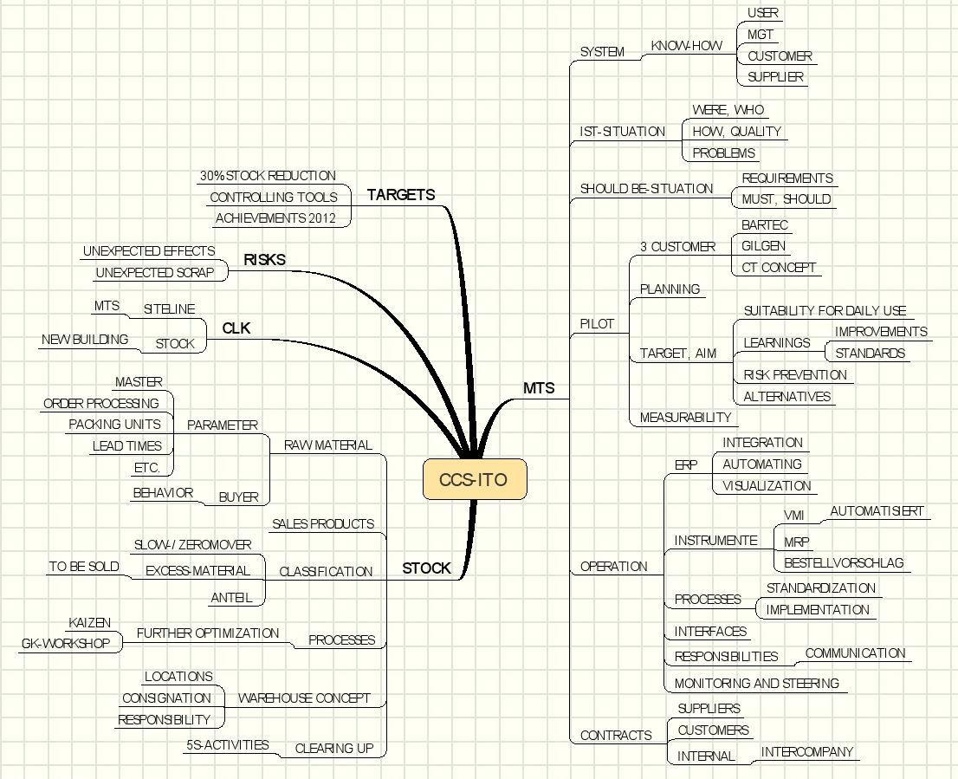

Project Organisation

Organizational chart

Organisation for Pilot Phase with 4 customers

Close collaboration with the responsible customer account manager during the pilot phase is recommended. This will give important inputs for operational integration and led to higher acceptance for the MTS-system. The pilot customers and the responsible persons are:

Bartec Georg Kern
Gilgen Urs Neuenschwander
CT Concept Alberto Della Schiava
Maxon – CLK direct business Peter Schmitt and Andreas Loosli

Points of Contact
Role | Name | Contact Number
Business Sponsor | CCS Holding
Steering Committee | Thomas Kaiser  TK | +41 32 387 9110  thomas.kaiser@ccsholding.com  Skype: thomas.kaiser.ccs
Steering Committee | Patrick Oldani  OLPA | +41 32 387 9107  patrick.oldani@ccsholding.com  Skype: patrick.oldani
Steering Committee | Daniel Lippuner  LIDA | +41 55 451 7840  daniel.lippuner@ccsholding.com  Skype:
Project Manager extern | Heinz Hirschi  HIH | +41 79 746 4945  heinz.hirschi@affinitas.ch  Skype: heinz.hirschi.ch
Project Manager intern | Thomas Fürst  FUT | +41 55 451 7901  thomas.fuerst@adaxys.com  Skype: thomas.fuerst.ccs
IT-Manager Navision | Dominique Chatton CHDO | +41 32 387 91..  dominique.chatton@ccsschweiz.com  Skype: --
IT-Manager IN:ERP | Roberto Bernasconi  BEB | +41 91 640 8456  roberto.bernasconi@adaxys.com  Skype: roberto.bernasconi.ccs
Logistic Expert | Tobias Heess  HET | +41 55 451 7882  tobias.heess@adaxys.com  Skype: tobias_heess
Process Owner,
see Site resp.
Site responsible  CLK  IT-Manager Syteline | Attila Antal  ANAT | Tel.: +94 31 487 1321  Mobile +94 77 368 4450  Attila.Antal@ccalanka.lk  Skype: attila.antal_ccs
Site responsible  CCS /CAH | Norbert Kovacs  KONO | +41 32 387 9135  norbert.kovacs@ccsschweiz.com  Skype: norbert.kovacs.ccs
Site responsible  CAM | Annamaria Fejes  FEA | +41 91 640 8224  annamaria.fejes@adaxys.com  Skype:
Pilot CCH-CLK | Georg Kern | +49 7641 933 5980  georg.kern@ccsdeutschland.com  Skype:georg_kern_ccs_deutschland
Pilot CCH-CLK | Urs Neuenschwander  NU | +41 32 387 9138  urs.neuenschwander@ccsschweiz.com  Skype: --
Pilot CCH-CLK | Peter Schmitt  SP | +41 79 310 49 00 peter.schmitt@ccsholding.com  Skype: peter.schmitt.ccs
Pilot CCH-CLK | Andreas Loosli  LOAN | +41 32 387 9120  andreas.loosli@ccsschweiz.com  Skype: andreas.loosli
Pilot CCS-CLK | Alberto Della Schiava | +41 32 387 9124  alberto.dellaschiava@ccsschweiz.com  Skype:
Skype users within CCS-Group:
CCS Point/CCS Board Infos & Newsboard/Groupwide_Tools/Skype/Skype_Users_CCS

Meeting Cycles

PL meeting
Meeting cycle: weekly (start-up phase)
Participants: Heinz Hirschi, Thomas Fürst, (optional: Patrick Oldani)
Responsible for invitation and agenda: Thomas Fürst
Mandatory: Minutes or task list of the meeting are made for every session

Project team meeting
Meeting cycle: tbd after setup phase
Participants: PL int+ext, project team members
Responsible for invitation and agenda: Thomas Fürst
Mandatory: Minutes of the meeting are made for every session

Steering committee
Meeting cycle: monthly
Participants: Steering Committee, PL, further on special invitation
Responsible for invitation and agenda: Thomas Fürst
Mandatory: Minutes of the meeting are made for every session

Project schedule and resources

Projectplan

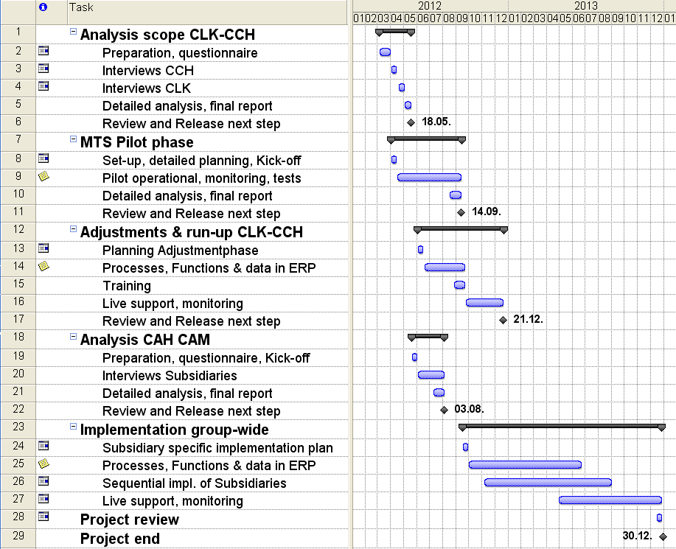

Comments related to project tasks:

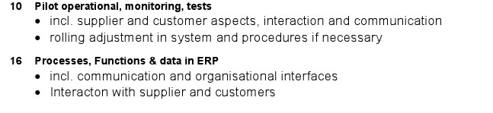

Project resources

The table shows the estimated FTE (Full Time Equivalent) of work load in this period

Project Controlling

Reports
Weekly report:
Word template
Responsible: Thomas Fürst (Heinz Hirschi)
Cycle: weekly
Receiver: Thomas Kaiser, Patrick Oldani
CC:

Resource report:
Excel report (rolling)
Responsible: Thomas Fürst (Heinz Hirschi)
Cycle: monthly
Receiver: Thomas Kaiser, Patrick Oldani
CC:

Costs, expenses and investments report:
Excel report (rolling)
Responsible: Thomas Fürst (Heinz Hirschi)
Cycle: monthly
Receiver: Thomas Kaiser, Patrick Oldani
CC:

Regulations for project documentation

All Documents are stored in CCS Point.
The following hyperlink guides you to the project folder:

CCS ITO Project Folder

Folder structure in CCS-Point:

01_Project Management
02_Meetings-Minutes
03_general Information
10_Analysis scope CLK - CCH
20_Implementation
30_MTS Pilot
40_Implementation CLK – CCH
50_Analysis group-wide
60_Implementation group-wide

